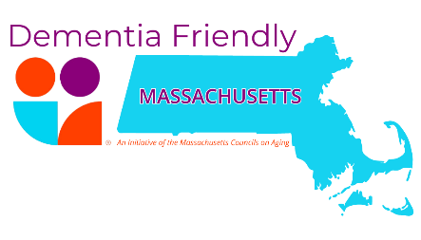
As members of the (City/Town) of (name of municipality) dementia friendly action team, we pledge to continue to take action to support, include, and welcome people living with dementia and their care partners, thereby optimizing their health, well-being and community engagement. We agree that every part of our community plays a role in improving our dementia friendly capabilities and together we can take steps to create a dementia friendly culture and facilitate the adoption of dementia friendly practices in all parts of (name of municipality).

We now hereby sign this pledge as a sign of our commitment to continue our efforts to make and sustain (name of municipality) as a Dementia Friendly Community we agree to:
- Step 1: Determine Community Readiness; Create an Action Team; Identify a Leader or Co-Leaders
- Step 2: Engage with Residents
- Step 3: Develop an Action Plan & Begin Implementation.
- Step 4: Be Recognized for your Commitment
Dated this (date) day of (month), (year)
Name & Title Signature
____________________________________ _______________________________________
____________________________________ _______________________________________
____________________________________ _______________________________________
____________________________________ _______________________________________
____________________________________ _______________________________________
____________________________________ _______________________________________
____________________________________ _______________________________________
____________________________________ _______________________________________
Who Should Sign?  The leader and members of the action team and at least one municipal leader or elected official | How to Submit  Scan signed copy and email to Madeline Noonan at madeline@mcoaonline.org or Hayley Wood at hayley@mcoaonline.org

